20.61: a) 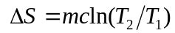
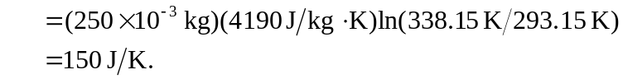

b) c) The sum of the result of parts (a) and (b) is 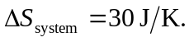 d) Heating a liquid is not reversible. Whatever the energy source for the heating element, heat is being delivered at a higher temperature than that of the water, and the entropy loss of the source will be less in magnitude than the entropy gain of the water. The net entropy change is positive.

